Werribee Mercy Hospital  COVID 19 Referral Form |  | Referral Date:

COVID -19 Program contact details
Fax number for all referrals: 8754 3339 Enquiries ph: 8754 6298

Service Requested
COVID-Positive Home Monitoring Program: □
Sotrovimab Monoclonal Antibody Infusion Clinic: □

Patient Details
Last/Family name: | First name:
Previous last name: | Sex: Choose an item.
Date of birth: | ATSI status: Choose an item.
Address: | Home telephone No.:
Suburb: | Mobile number:
Postcode: | Email:
NOK/Carer: | Preferred contact method:
NOK relationship: | Medicare no.:
NOK contact no.: | Pensioner/Concession/Health/DVA No.:
Interpreter required: ☐ Yes ☐ No Specify language:
Previous Mercy patient: ☐ Yes ☐ No | Mercy UR Number (if known):
The patient has agreed to the referral and the sharing of their personal and health information with the health service ☐ Yes ☐ No

Referring Doctor Details
Referring Doctor: |  |  | Provider number:
Practice Name:
Practice Address:
Suburb:
Postcode: |  |  | Phone No:
Email: |  |  | Fax:
Preferred method of communication:

Patient’s usual GP (if not the same as referring doctor)
Name: |  | Clinic:

Clinical information

Allergies: COVID-19 Vaccination Status:
Height (cm): Weight (kg): BMI:
Date of symptom onset: Date of COVID-19 Test:

Current medication

Drug name | Ltd. elapse | Strength | Dose / frequency / special
Past medical history

Relevant social history

Planned location of administration: Werribee Mercy – COVID-19 Infusion Clinic
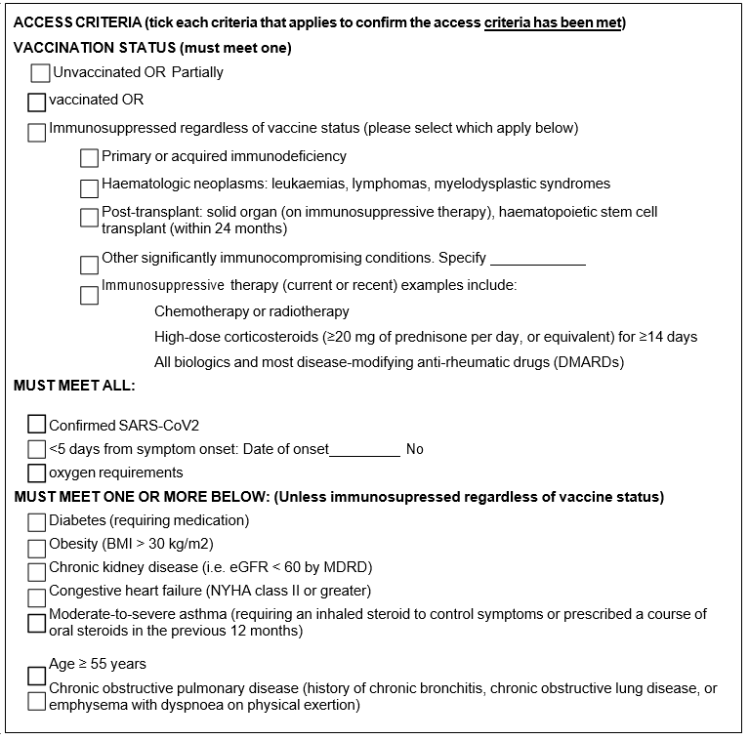
Doctor’s signature: |  | Date:

IMPORTANT NOTICE – PRIVILEGED AND CONFIDENTIAL MESSAGE
This facsimile transmission is intended for the exclusive use of the person or hospital to which it is addressed and may contain information that by law is privileged or confidential. If the reader of the facsimile transmission is not the intended recipient, you are hereby notified that any disclosure, distribution of copying of this transmission is prohibited by law, and the contents must be kept strictly confidential. If you have received this transmission in error, kindly notify us immediately and return the original to us at the above address.
This form constitutes a valid referral to Werribee Mercy Hospital provided all requested details are complete.

References
- https://www.clinicalguidelines.gov.au/portal/2604/australian-guidelines-clinical-care-people-covid-19

